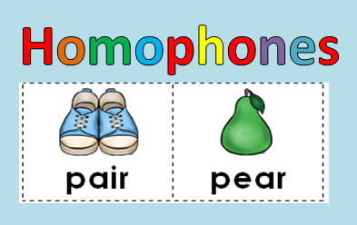

_________________________ Book of Homophones

